Module 05 Lab 02 Model Evaluation and Refinement Laptop Pricing Screenshot Evidence and Discussion
Reference label for this notebook: Lab2 (each heading below is numbered Lab2_1, Lab2_2 and so on).
This document gathers the screenshots of Module 05 Lab 02, model evaluation and refinement on the laptop pricing dataset, with a heading for each of the four tasks. The lab prepares the data, uses cross validation for a single variable model, looks for the overfitting point with polynomial features and finishes with Ridge regression and a GridSearchCV over alpha. Each screenshot file name is printed below its image.

Lab2_1. Section 0 Installing seaborn
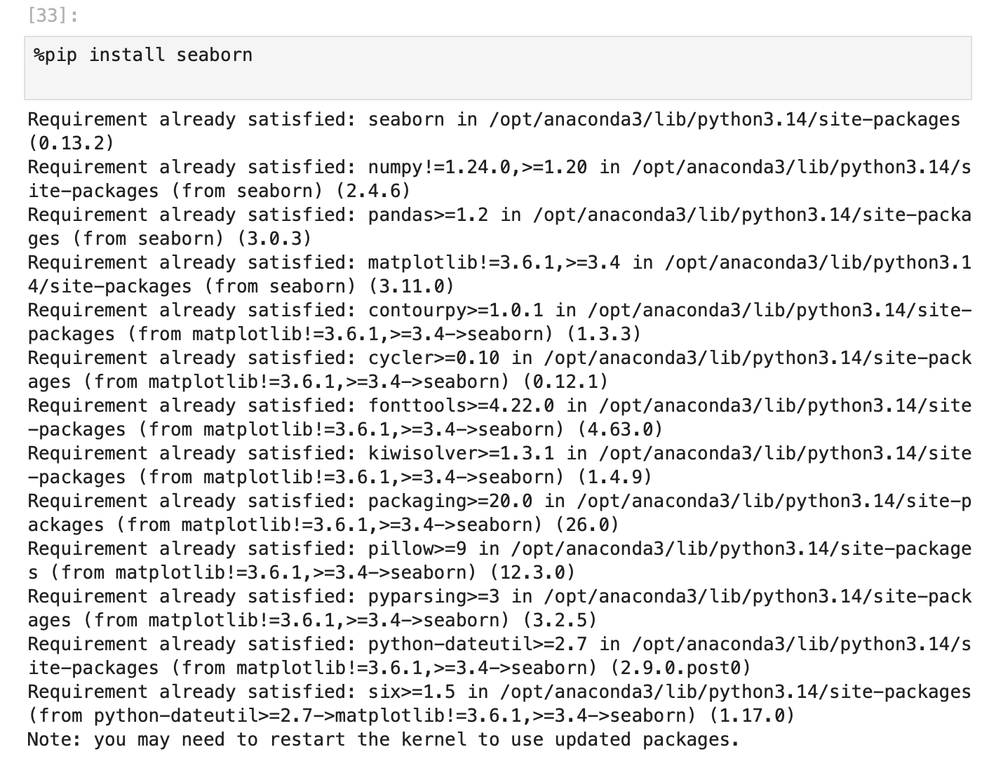
Screenshot file: 01_pip_install_seaborn.png
The installation cell makes seaborn available in the environment, since the later sections use it for the distribution plots.

Lab2_2. Section 0 Importing the required libraries
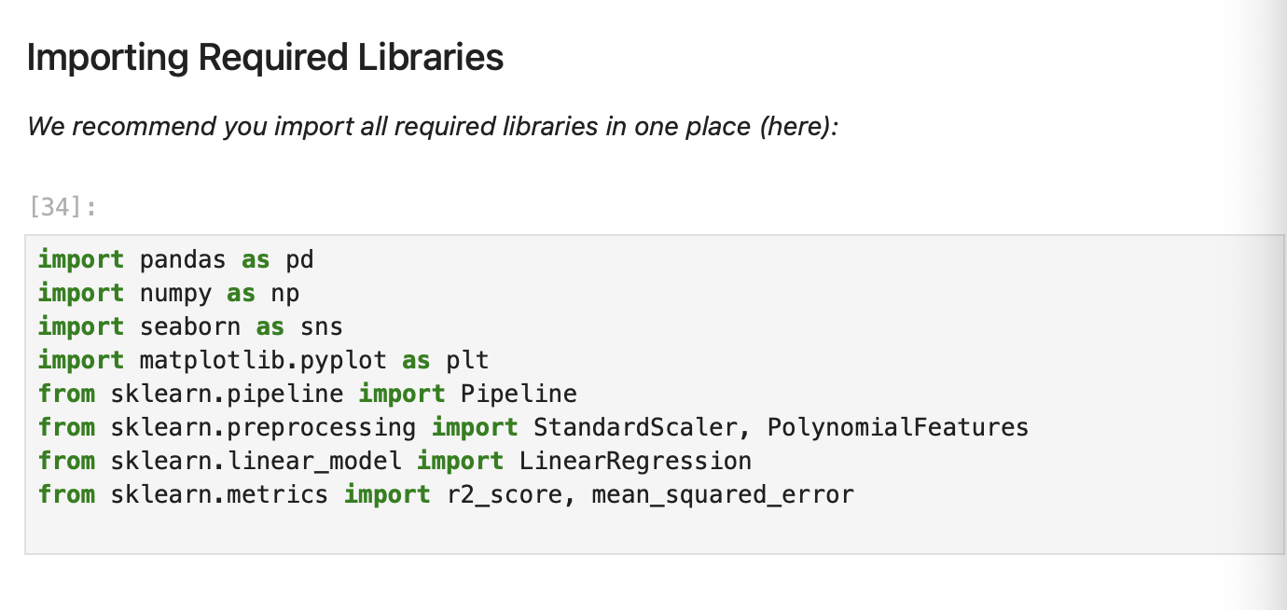
Screenshot file: 02_import_required_libraries.png
The import cell brings in pandas, numpy, matplotlib, seaborn and the scikit-learn estimators used throughout the lab.

Lab2_3. Section 1 Downloading the dataset
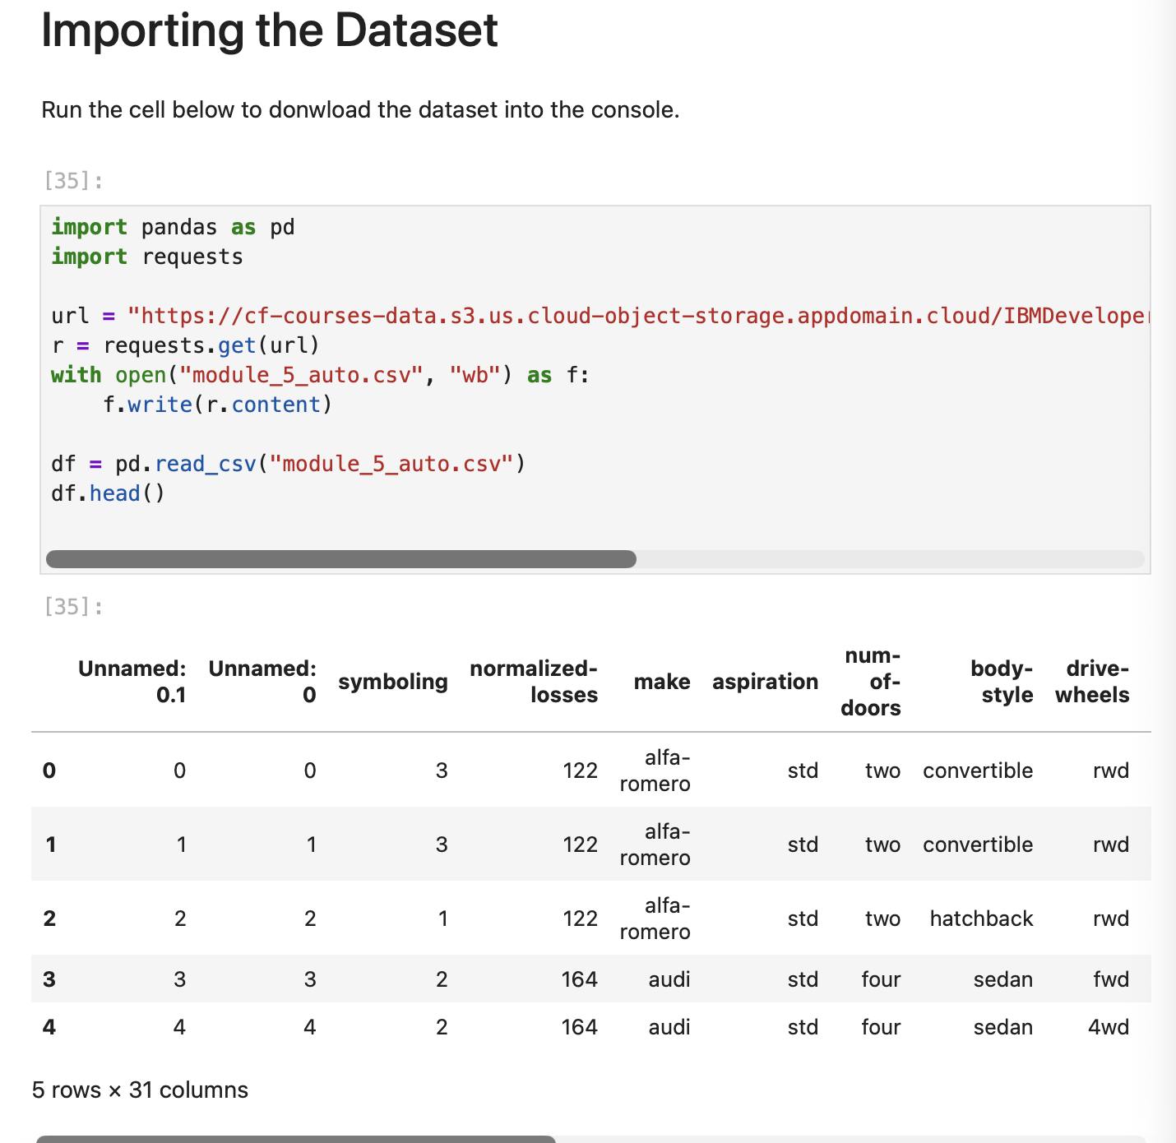
Screenshot file: 03_import_the_dataset.png
The prepared laptop dataset is fetched from the course URL and stored locally so the notebook can read it.

Lab2_4. Section 1 Reading the CSV and previewing the frame
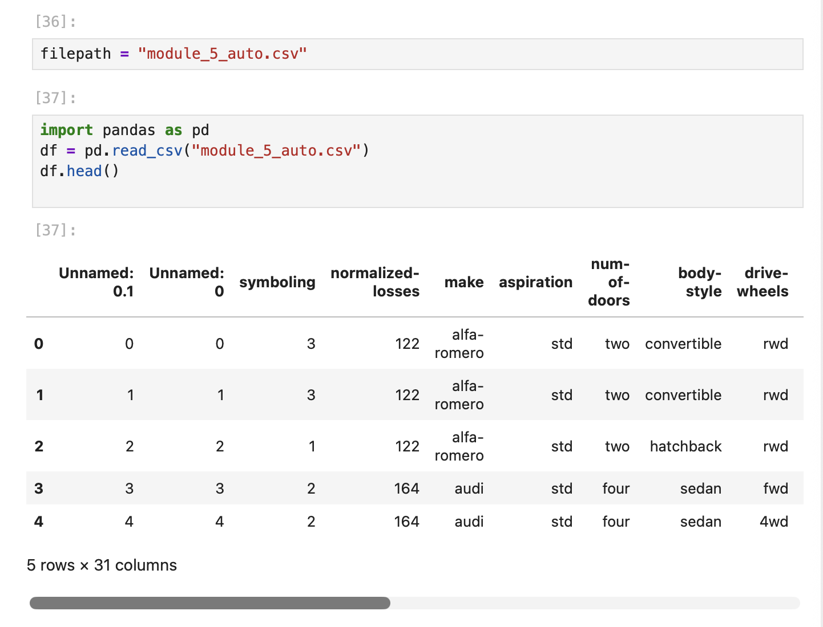
Screenshot file: 04_read_csv_df_head.png
pd.read_csv loads the file into df and df.head() shows the first rows of the laptop data.

Lab2_5. Section 1 Reading the CSV with its header row
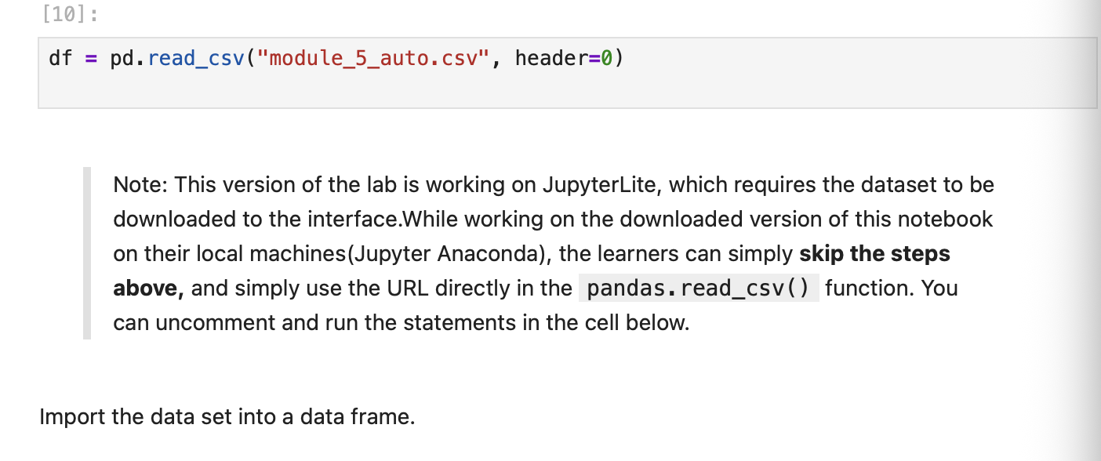
Screenshot file: 05_read_csv_with_header0.png
The note explains the JupyterLite download step; the cell reads the file with header = 0 so the column names come from the file.

Lab2_6. Section 1 Printing the head of the dataframe
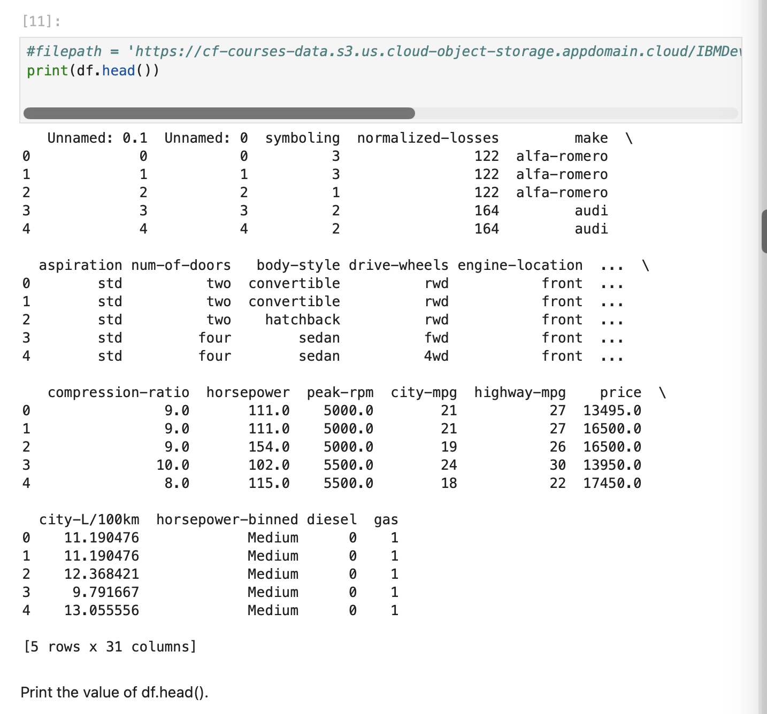
Screenshot file: 06_print_df_head.png
print(df.head()) displays the first rows in plain text, which confirms the columns and the sample values.

Lab2_7. Section 1 Dropping the unnamed index columns
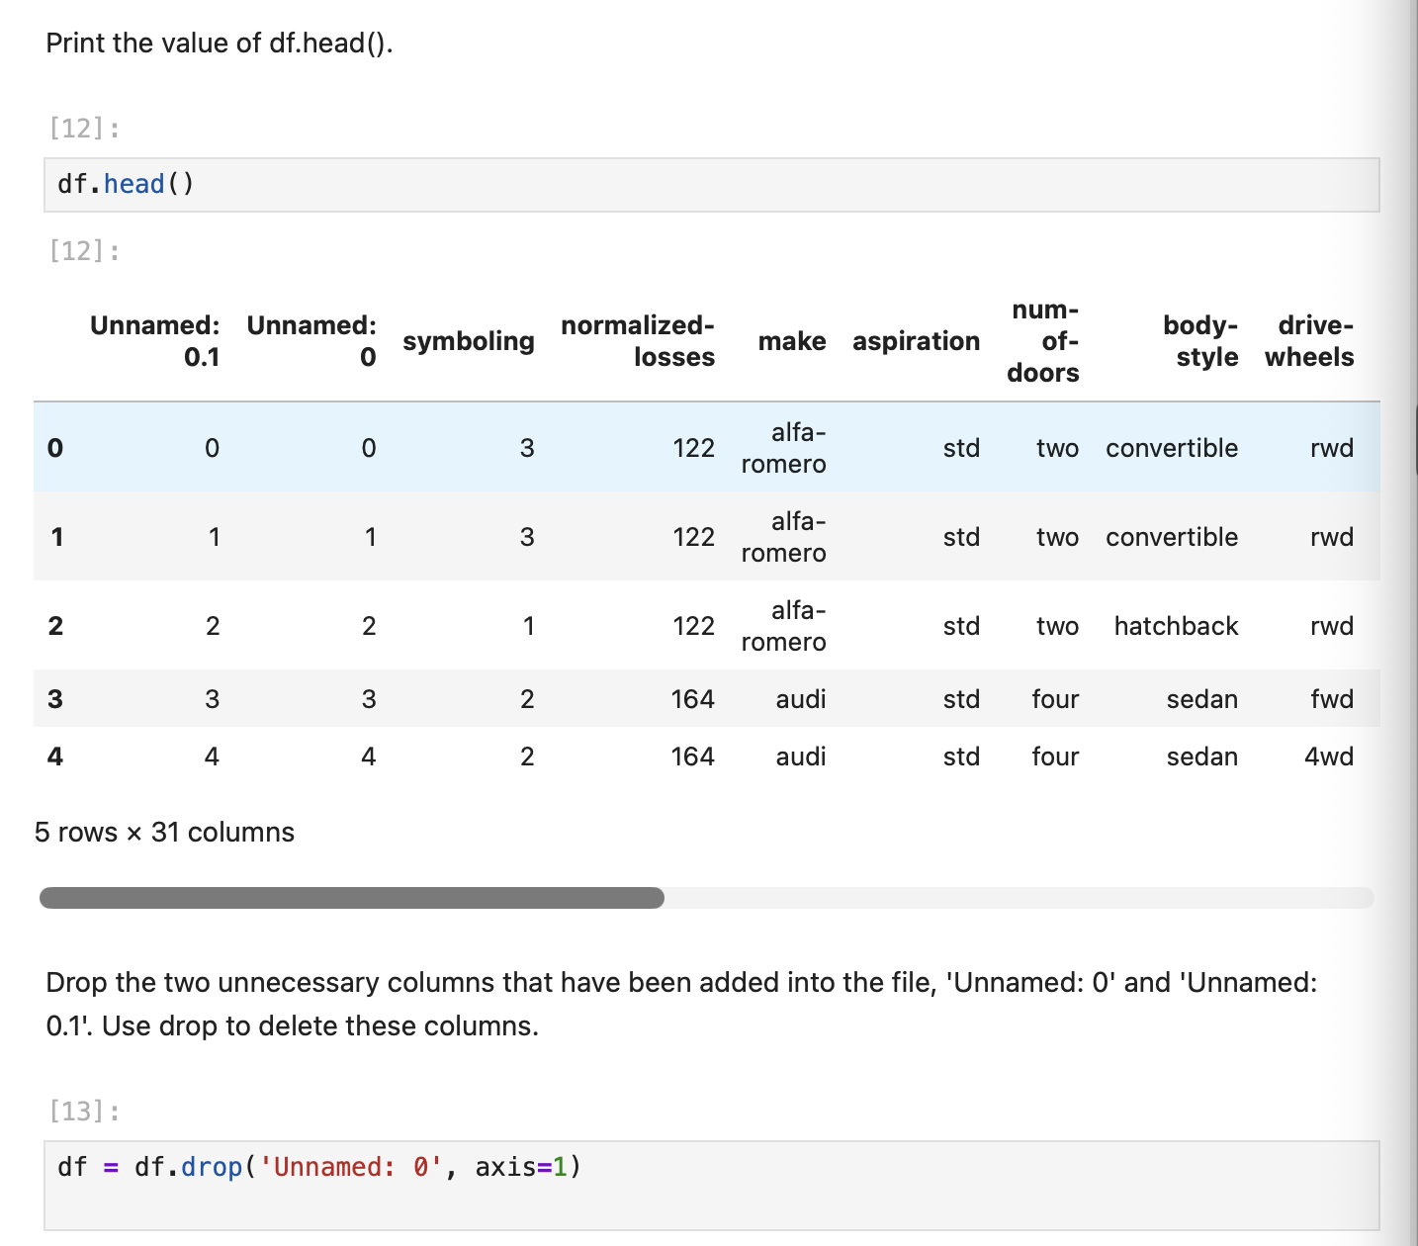
Screenshot file: 07_drop_unnamed_columns.png
The two columns Unnamed: 0 and Unnamed: 0.1 are removed from the frame, which cleans the leftovers of the exported CSV.

Lab2_8. Section 1 Dropping the index columns and reading the file from the URL
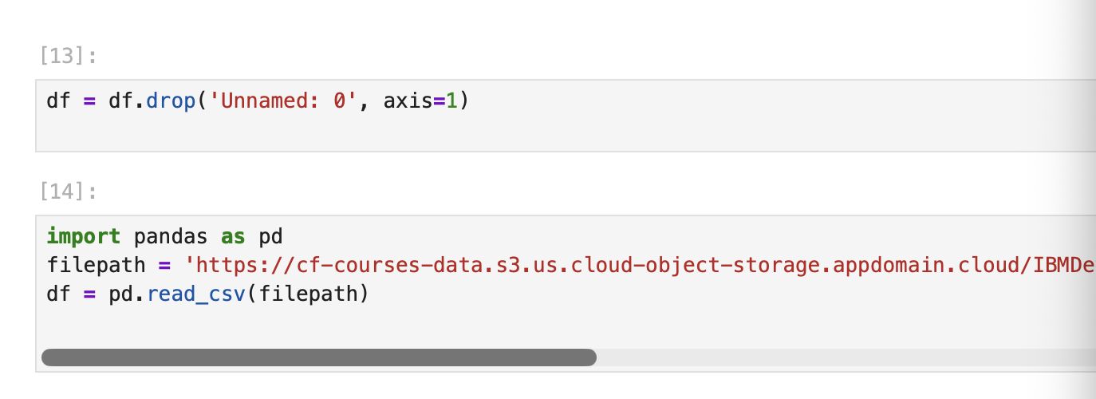
Screenshot file: 08_drop_unnamed0_and_read_csv_url.png
The same drop is shown together with the read from the course URL, which is the local machine route through the setup.

Lab2_9. Task 1 Dividing the data into features and target
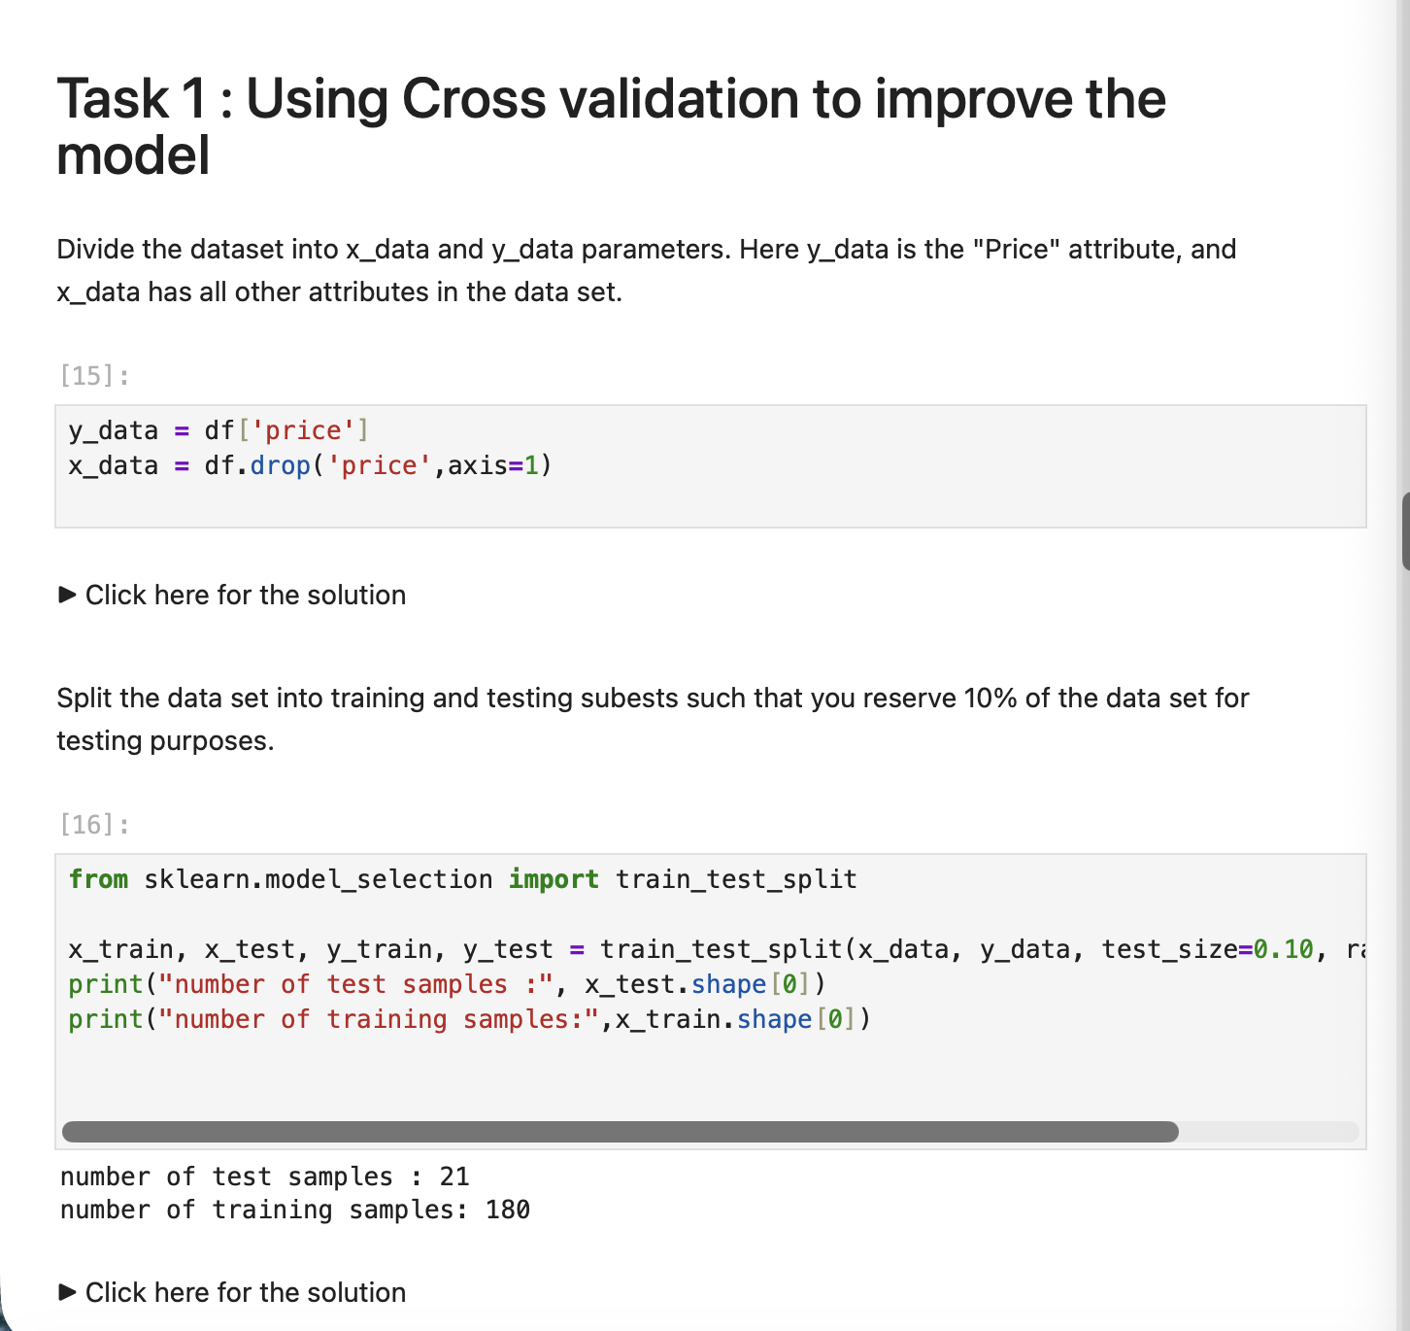
Screenshot file: 09_train_test_split_data.png
x_data receives all the attributes and y_data the Price column, the split that every model in the lab uses.

Lab2_10. Task 1 Single variable linear regression with cross validation
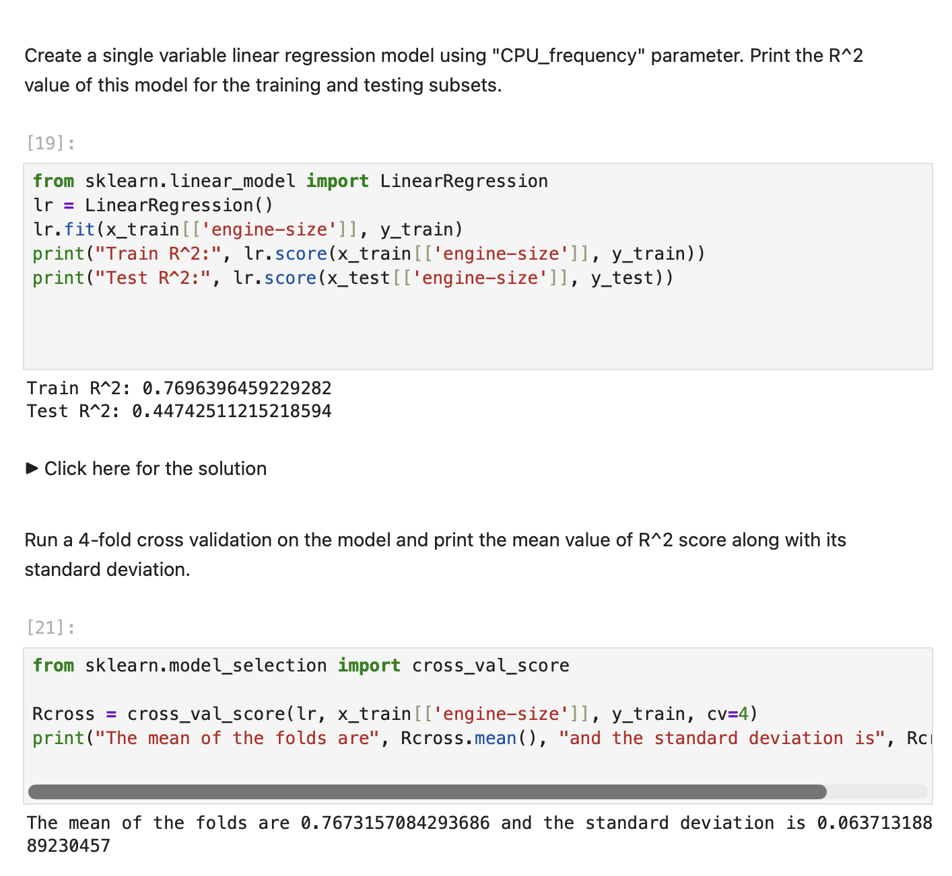
Screenshot file: 10_linear_reg_engine_size_cross_val.png
A linear regression on CPU_frequency is fitted and evaluated with cross validation, which gives a more stable score than a single split.

Lab2_11. Task 2 Polynomial features of increasing degree
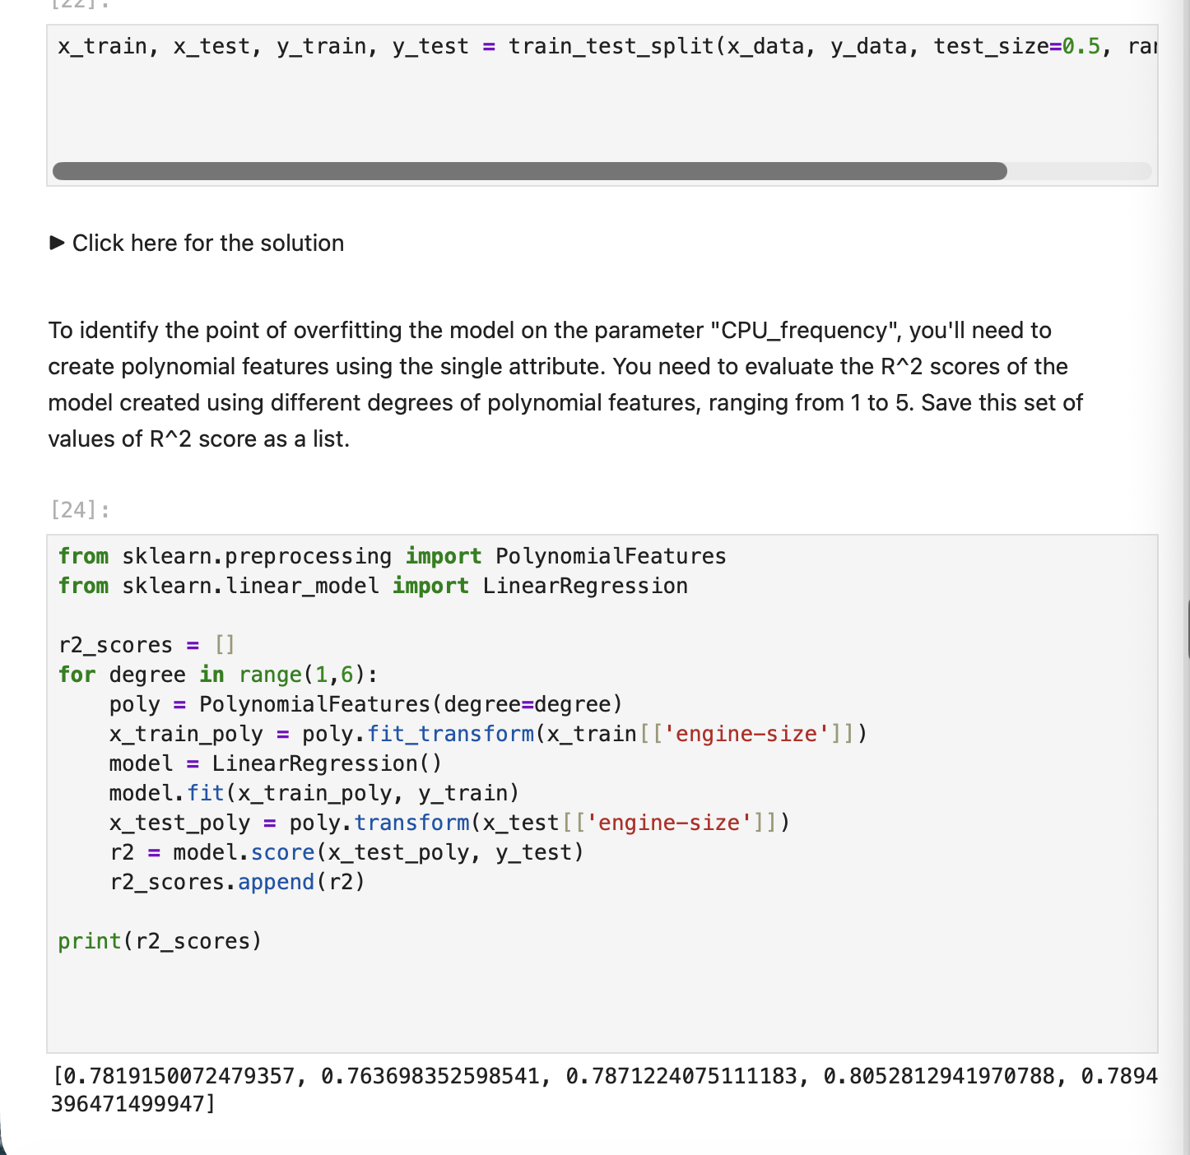
Screenshot file: 11_polynomial_features_r2_scores.png
Polynomial features are generated for CPU_frequency and the R squared is recorded for each degree, which is how the point of overfitting is found.

Lab2_12. Task 2 Plotting R squared against the polynomial order
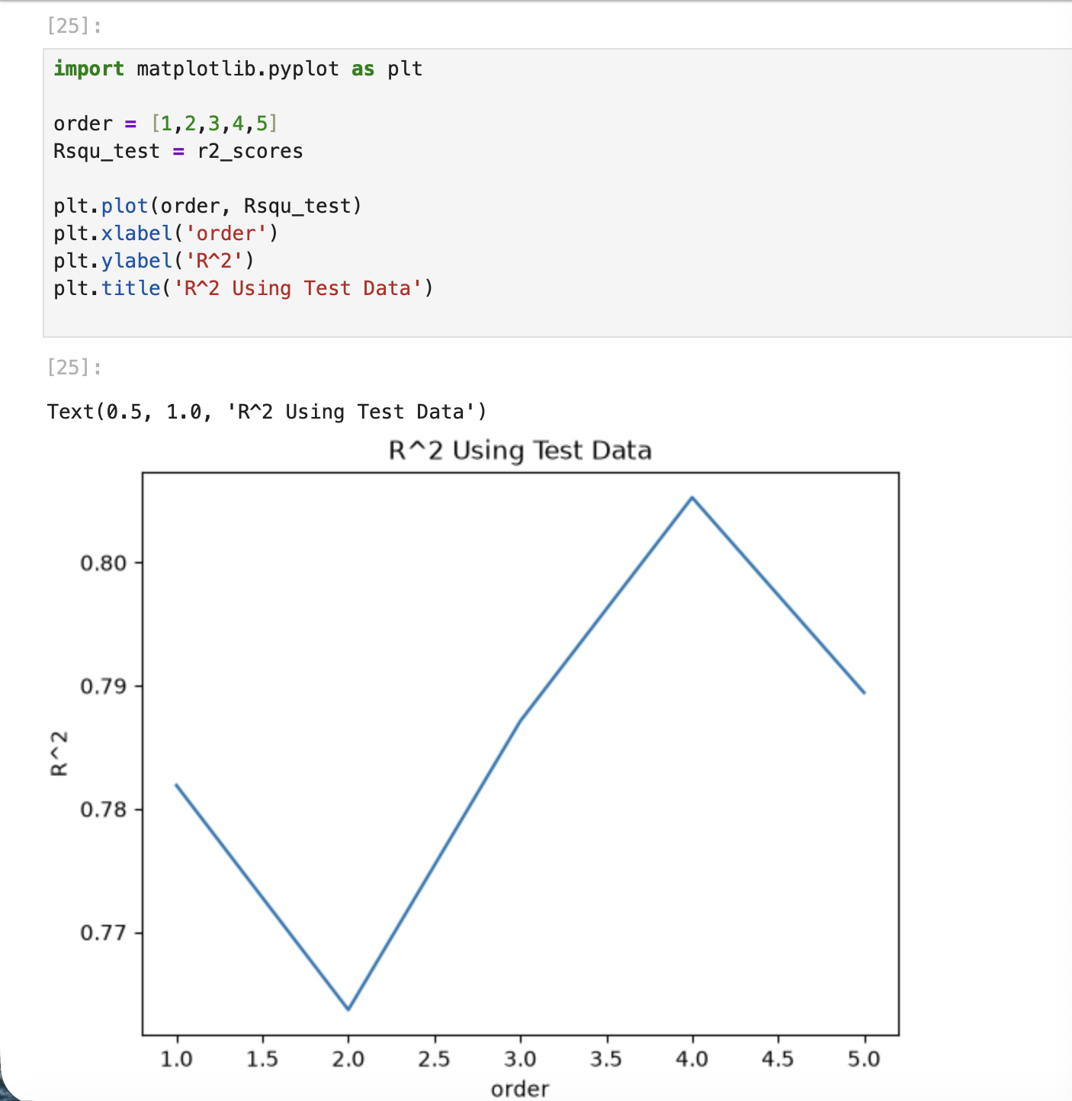
Screenshot file: 12_plot_r2_test_poly_order.png
The test R squared is plotted against the degree of the polynomial; the curve peaks and then falls, marking the overfitting point.

Lab2_13. Task 3 Ridge regression with second order polynomial features
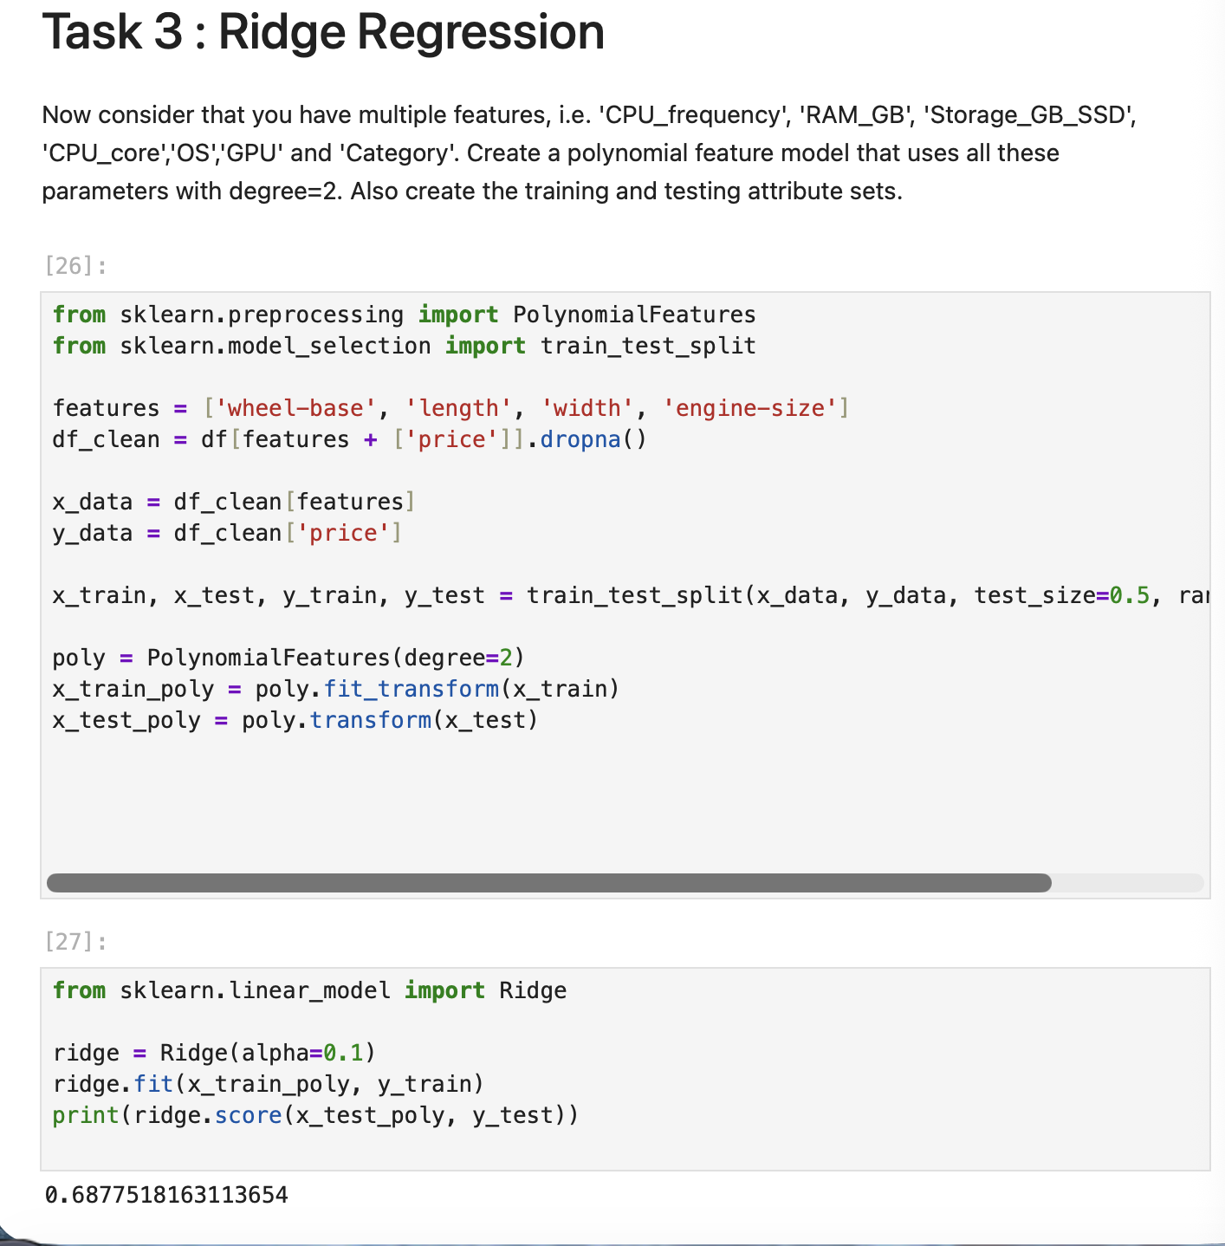
Screenshot file: 13_ridge_regression_poly2.png
Ridge regression is fitted on the polynomial features of the six selected attributes, which regularises the coefficients.

Lab2_14. Task 3 Training and test R squared against alpha
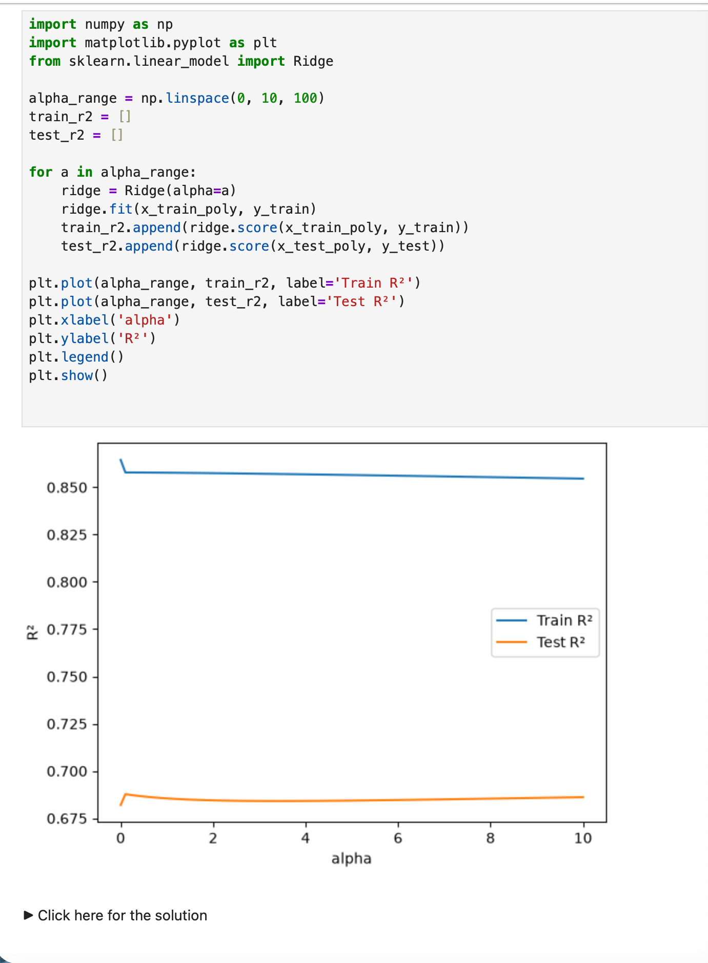
Screenshot file: 14_ridge_alpha_plot_train_test_r2.png
The two curves show how the training and test scores change with the regularisation strength, and where the model starts to underfit.

Lab2_15. Task 4 Preparing the grid search over alpha
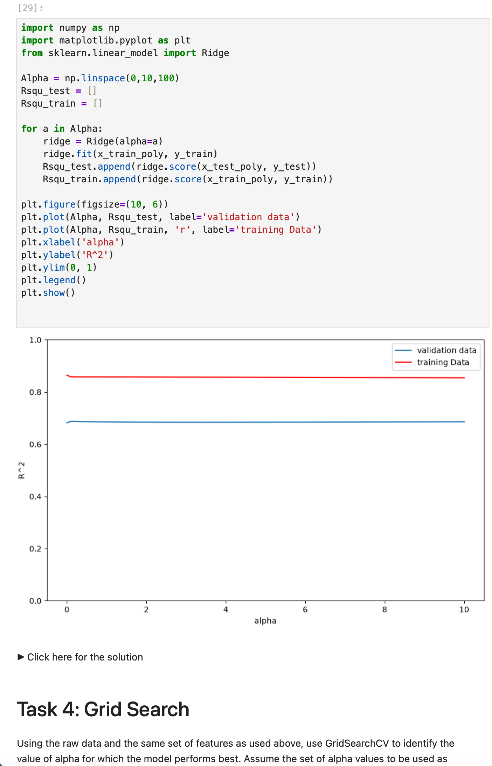
Screenshot file: 15_ridge_alpha_gridsearch_prep_plot.png
GridSearchCV is imported and the grid of alpha values is defined, which replaces the manual loop over alpha.

Lab2_16. Task 4 Grid search with four fold cross validation
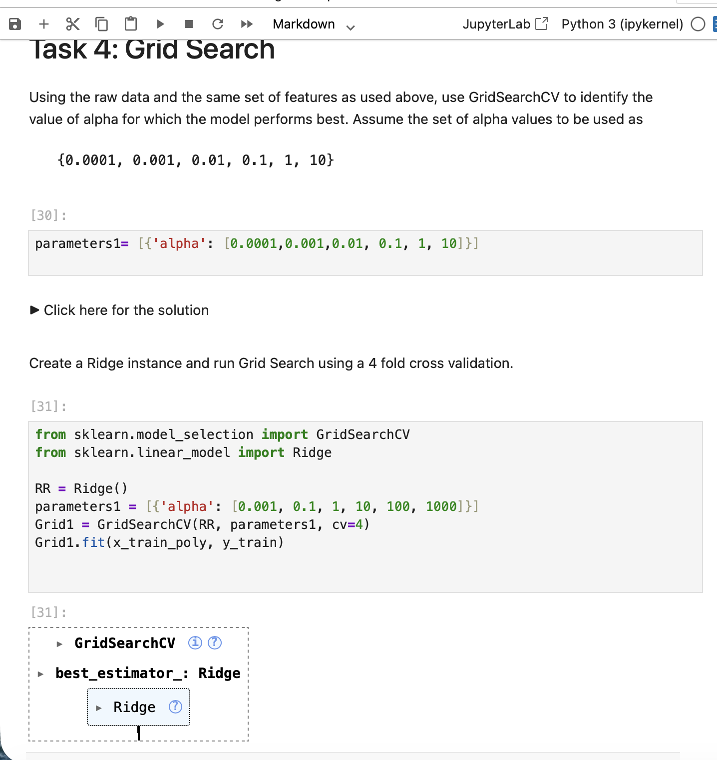
Screenshot file: 16_gridsearchcv_ridge_4fold_cv.png
The search object is fitted on the training data with four folds, so every candidate value of alpha is evaluated on each fold.

Lab2_17. Task 4 Best ridge model and its test R squared
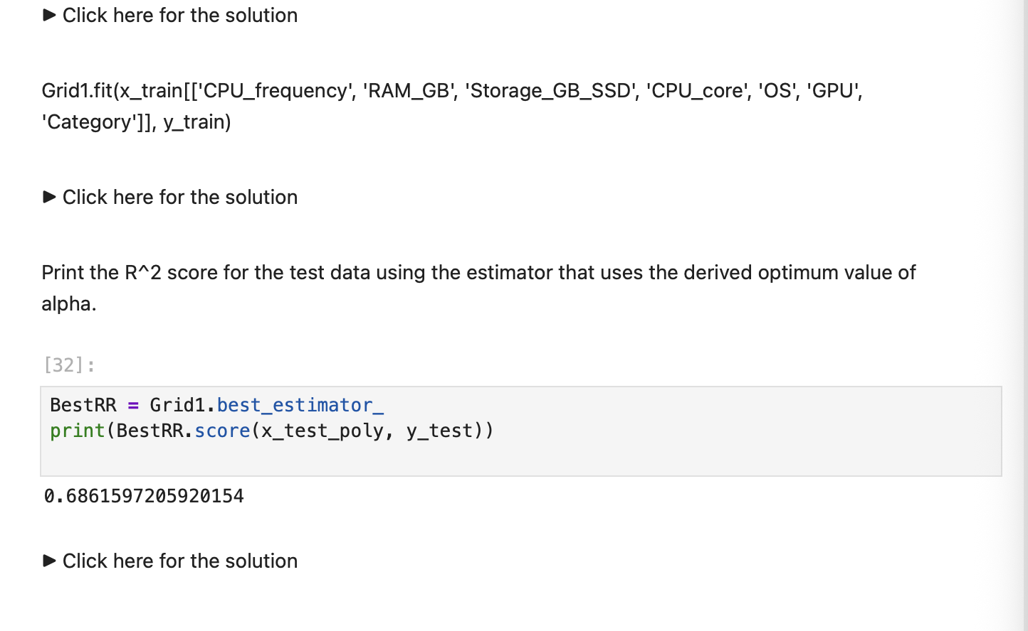
Screenshot file: 17_gridsearch_best_ridge_test_r2.png
The best estimator is extracted and scored on the test data, which reports the performance of the tuned model.

